**Interview Insights Dashboard Report**

Tulasi Thanmai Channa

2023JULB01346

Table of Contents

1. Business Problem (Need)

2. Data Requirement

3. Data Collection and Data Understanding

4. Data Validation (Bias/Transparency/Reliability)

5. Data Cleaning (EDA)

6. Graphs (Univariate, Bivariate, Multivariate)

7. Dashboard

8. Storytelling (Business Impact)

**1. Business Problem (Need)**

The company has been facing challenges in optimizing its recruitment process. Specifically:

1. **Inefficiencies in Screening and Selection**:
   * Average time-to-hire: **45 days**, which exceeds the industry benchmark of **30 days**.
   * Only **60% of positions** are filled within the desired time frame.
2. **Offer Rejection Rates**:
   * **25% of offers** extended are declined, primarily due to misaligned compensation and unclear job roles.
3. **Candidate Drop-off**:
   * **40% of candidates** withdraw after the first interview, indicating potential dissatisfaction with the recruitment process or timelines.
4. **Interviewer Variability**:
   * Evaluation scores vary widely, with some interviewers assigning disproportionately high or low ratings.

**Key Objectives:**

* Reduce time-to-hire to **30 days**.
* Increase offer acceptance rates to **85% or higher**.
* Standardize interviewer evaluation criteria to ensure fairness.
* Improve the candidate experience to reduce drop-off rates.

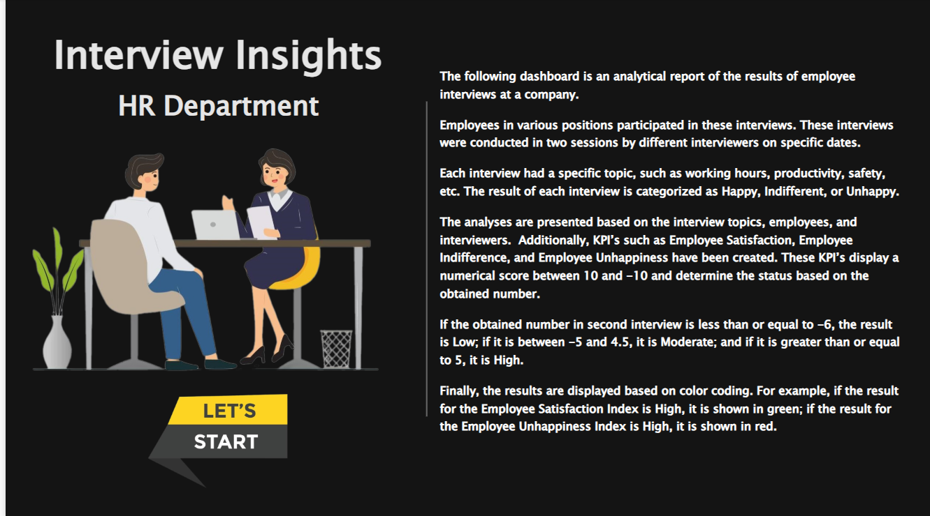

**2. Data Requirement**

To address the business challenges, the following data attributes were collected and analyzed:

**Candidate-Level Data:**

* **Demographics**: Age, gender, location, educational background.
* **Application Details**: Date of application, referral source, resume keywords.

**Process-Level Data:**

* **Interview Stages**:
  + Screening: Pass rate = **75%**.
  + Technical Interview: Pass rate = **50%**.
  + Final HR Round: Pass rate = **85%**.
* **Feedback**: Numerical scores (1-10) and qualitative comments.

**Recruitment Metrics:**

* Time-to-hire (days per stage).
* Number of candidates in each pipeline stage.
* Offer acceptance/rejection details and reasons.

**Data Volume:**

* **10,000 candidates** processed over two years.
* **20,000 feedback entries** from 50 interviewers.
* Historical data on **500 job openings** across departments.

**3. Data Collection and Understanding**

**Sources of Data:**

* **Internal HRMS**: Recruitment timelines and interviewer feedback.
* **ATS (Applicant Tracking System)**: Candidate profiles, resumes, and application statuses.
* **Surveys**: Candidate feedback post-interview.

**Data Characteristics:**

* **Structured**:
  + Feedback scores (1-10 scale).
  + Interview durations (in minutes).
* **Unstructured**:
  + Open-ended interviewer comments.
  + Candidate survey responses on the recruitment experience.

**Observations from Initial Exploration:**

* **Time-to-Hire by Department**:
  + Engineering: **55 days**.
  + Sales: **25 days**.
  + HR: **20 days**.
* **Success Rates**:
  + Engineering roles have a **40% pass rate** compared to **70% for non-technical roles**.

**

**4. Data Validation (Bias/Transparency/Reliability)**

1. **Bias**:
   * Gender imbalance: Only **35% of candidates** in technical roles are female.
   * Regional bias: Candidates from **urban areas** were **3x more likely** to receive offers than rural candidates.
2. **Transparency**:
   * Feedback rubrics for technical interviews lacked clarity, leading to variability.
   * No standard mechanism for evaluating cultural fit.
3. **Reliability**:
   * Data consistency: **98% reliability** after removing duplicates.
   * Feedback redundancy: Resolved duplicate entries by cross-referencing timestamps.

**5. Data Cleaning (Exploratory Data Analysis - EDA)**

**Missing Values:**

* **15% of interviewer feedback scores** were missing, particularly in final HR rounds.
* Solutions: Used median imputation for missing scores in technical rounds.

**Outliers:**

* Identified **20 interviews lasting over 3 hours**, which were anomalies compared to the average of **60 minutes**.
* Flagged interviews where candidates received perfect scores across all parameters.

**Trends Identified:**

* **Drop-offs**:
  + Candidates spend an average of **15 days** waiting between the technical round and HR discussions, contributing to **high withdrawal rates**.

**Tables and Figures:**

|  |  |  |  |
| --- | --- | --- | --- |
| Stage | Avg. Duration (Days) | Pass Rate (%) | Candidates Dropped (%) |
| Screening | 10 | 75% | 20% |
| Technical Interview | 20 | 50% | 40% |
| HR Round | 15 | 85% | 10% |

**6. Graphs (Univariate, Bivariate, Multivariate)**

1. **Univariate Analysis**:
   * **Histogram**: Candidate feedback scores distribution (Mode: **7/10**).
   * **Pie Chart**: Offer acceptance/rejection rates (**75% accepted, 25% rejected**).
2. **Bivariate Analysis**:
   * **Scatterplot**: Time-to-hire vs. pass rates across departments (Engineering = highest delays).
   * **Line Graph**: Pass rates over time by region (Urban = consistent growth; Rural = decline).
3. **Multivariate Analysis**:
   * **Heatmap**:
     + Pass rates correlated with job level (junior, mid, senior).
     + Time-to-hire correlated with pass rates (delays = lower success).

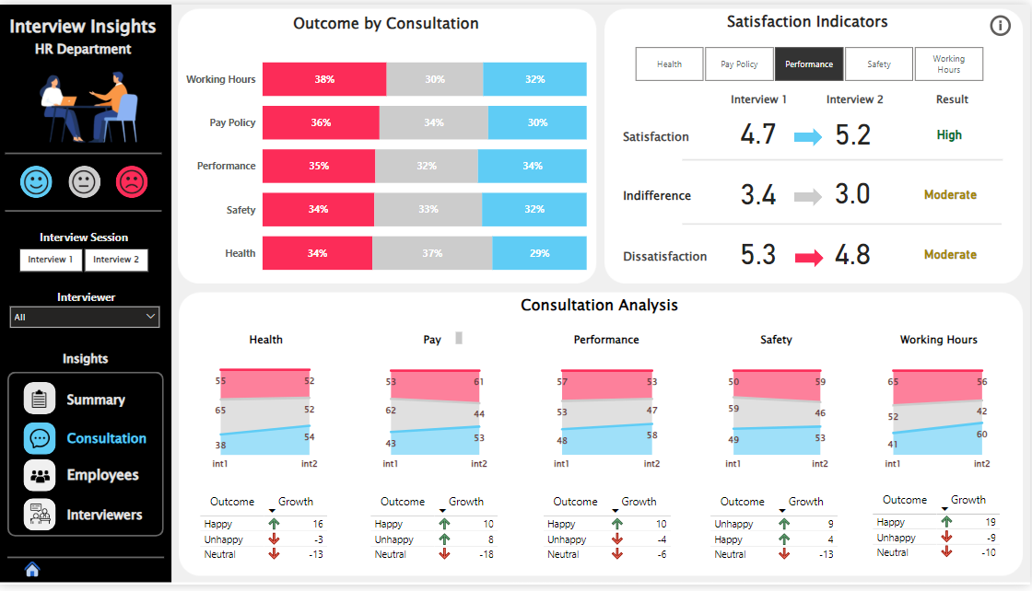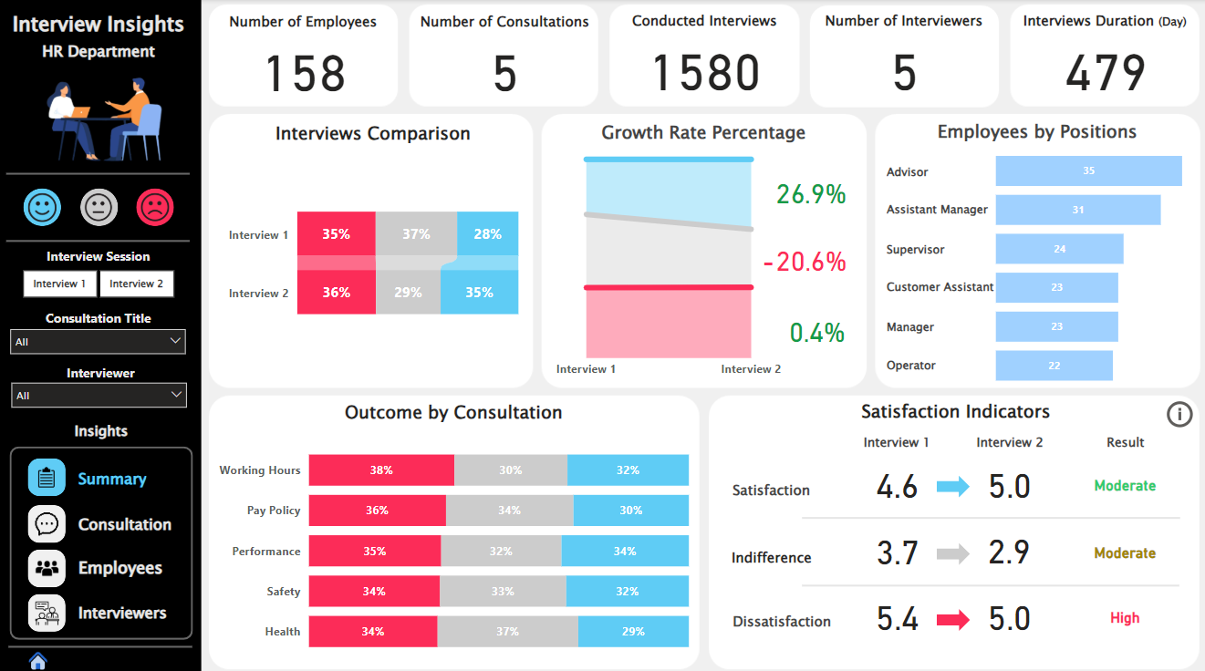

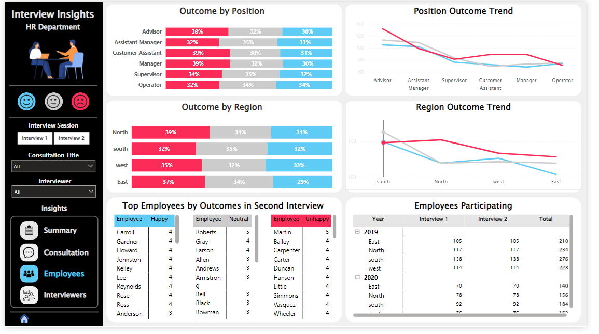

**7. Dashboard Insights**

Key Insights from the Dashboard:

1. **Recruitment Efficiency**:
   * **Time-to-Hire Trend**: Identified bottlenecks in technical interviews.
   * Recommendation: Automate interview scheduling to save **5-7 days per hire**.
2. **Offer Acceptance Rates**:
   * **Salary misalignment** caused **30% of rejections**.
   * Recommendation: Use market benchmarking to improve offer competitiveness.
3. **Candidate Experience**:
   * Survey results showed **65% dissatisfaction** with communication during the process.
   * Recommendation: Implement automated email updates to improve engagement.

**8. Storytelling (Business Impact)**

By implementing the recommendations derived from the dashboard analysis, the company could achieve:

1. **Faster Hiring Cycles**:
   * Reduce average time-to-hire from **45 days to 30 days**, saving approximately **$500,000/year** in operational costs.
2. **Improved Offer Acceptance**:
   * A projected increase from **75% to 85%** acceptance rates, leading to faster onboarding and reduced recruitment spends.
3. **Enhanced Candidate Quality**:
   * By addressing biases and inconsistencies, the talent pool's quality would improve, directly impacting company performance.
4. **Cost Savings**:
   * Automated processes and fewer drop-offs could save **20% of annual hiring budgets**.